FINGAL COUNTY COUNCIL GRADUATE AWARD OPPORTUNITY 2014 IN PARTNERSHIP WITH BLOCK T
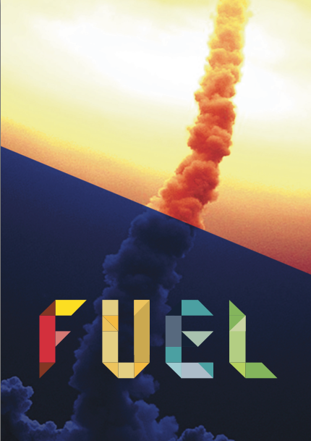
BLOCK T and Fingal County Council Arts Office are delighted to announce a new collaboration as part of FUEL, BLOCK T’s Visual Arts Programme dedicated to the support and professional development of recent graduates.

As part of an ongoing commitment to professional artists Fingal County Council’s Arts Office are offering a one-year Graduate Studio Award in BLOCK T with a Solo Exhibition in the BLOCK T Gallery in 2015.

This residency will be offered to one graduate, the opportunity is part of a series of initiatives by Fingal Arts to promote and support the professional practice of emerging artists. It will provide an ideal environment for the development of a graduates practice and an opportunity to network with other artists.

FUEL was launched in 2013, and is an integral element of BLOCK T’s Visual Arts Programme that hosts a series of Events, Activities and Awards supporting the professional development of students and recent graduates of the Visual Arts. In September 2013, FUEL hosted an exhibition of selected work by recent graduates from a number of Irish colleges in BLOCK T and a one day professional development workshop Fuelling the Future which brought together a group of established arts professionals, who addressed some of the concerns and challenges that face recent graduates and emerging artists.
This new collaborative award between Fingal Arts and BLOCK T will be made in addition to the BLOCK T Graduate Award and forms a part of the FUEL programme.
Criteria:
Fingal County Council Graduate Award is based on an open submission for under & post graduate students graduating in 2014. To apply for this award the graduate must live in, be originally from or have studied in Fingal and submit the following:

1.Personal Details
Name of Applicant:
Contact Address:
Mobile:
E-mail:
Web:

2 Supporting Information
Please provide a short biography of up to 700 words, this should include briefly your education.

3 Current Practice
In more detail please tell us about the nature of your current practice, your ideas and how you are exploring and developing them through your work. (no more than 1 page A4)

4. Summary of Award Proposal
Please give a full description of how you propose to use the award opportunity at BlockT describing how the opportunity will impact and effect your artistic practice and current research, what benefits do you anticipate the residency will bring to you professionally. (max 1 page A4).

5.Supporting Visual Material
Please submit good quality visual examples of your work that demonstrate your arts practice to date. All still and moving images should be clearly labelled with a brief description of the work. Depending on the media used in your practice the following should be used as a guide:
Ten good quality still images, including detailed images or installation shots for installation work.

For further information please contact 01 8906237 or email sarah.oneill@fingalcoco.ie www.fingalarts.ie

The closing date for applications is Friday 1 August 2014

Please return all applications to:
Sarah O’Neill
Deputy Arts Officer
Fingal Arts Office
Fingal County Council
Civic Offices
Grove Road
Blanchardstown
Dublin 15

