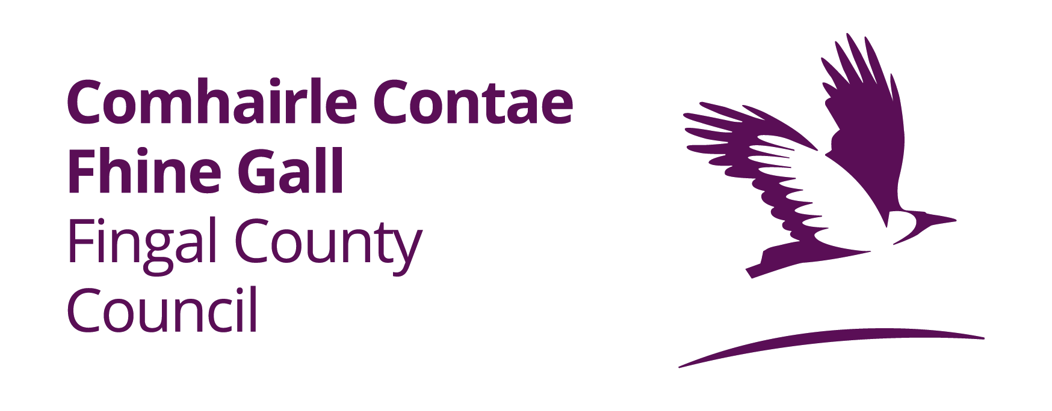
FINGAL’S CREATIVE IRELAND PROGRAMME 2021

ELIGIBILITY CRITERIA &
APPLICATION FORM
INTRODUCTION

Creative Ireland 2017-2022 is a five year Government initiative which places creativity at the centre of public policy. Creative Fingal is the local application of this initiative across the Fingal area.

WHO CAN APPLY?

As part of Fingal’s 2021 Creative Ireland programme, Fingal County Council invites applications from individuals and groups with not for profit projects which creatively explore at least one of the following themes;

Community Wellbeing and Culture
- Heritage (which may include historical exploration)
- Music
- STEAM (science, technology, engineering, arts and mathematics)
- Irish language

It is envisaged that the awards will be made in the region of €3,000 - €10,000.

CONDITIONS/CRITERIA

- Applications will be accepted on the official application form only.

- Applications may only be made for projects taking place in the Fingal Area.

- Projects must be completed by 1st November 2021.

- Selection Criteria will include:
(a) The extent to which the proposed event/project is aligned to the Creative Ireland Programme Pillar - 'Enabling Creativity in Every Community';
(b) The extent to which the proposed event/project maximises community and citizen engagement;
(c) The extent to which the proposed event/project is ambitious, innovative and fosters creativity;
(d) The potential scope of the event/project and anticipated target audience;
(e) The cost of the proposed event/project and any additional supports and funding that may be required or have been confirmed; and
(f) The feasibility of completing the project within the specified time frame.

- All projects will be evaluated using the following marking scheme

1 | Addressing a number of themes | 125
2 | Level of Community and citizen engagement (a) (b) (d) | 250
3 | Scale of project in terms of ambition, innovation and fostering creativity. (c) | 250
4 | Costing- value for money (e) | 175
5 | Project management – The feasibility of completing the project (f) Organiser(s) must provide evidence of and have a clear plan for delivering the project | 200
 | Total | 1000

- All recipients of grant assistance under the Creative Ireland scheme for projects involving children or young people must have appropriate policies in place as regards Child Protection. Fingal County Council will also require confirmation that the appropriate insurance policies and Health and Safety Procedures are in place.

- Grant aid provided by Fingal County Council for the Creative Ireland initiative must be acknowledged in all publicity material associated with the project. We reserve the right to publicise the awarding of the Creative Fingal Project Awards.

Failure to acknowledge appropriately may deem the award invalid and support received may need to be refunded to Fingal County Council. All successful applications will receive a copy of Fingal County Council and Creative Ireland logos, along with the requirements for acknowledging the award.

- Assistance shall not be given in respect of commercial activities.

- Payment will not be made for activities commenced prior to approval.

- All applicants will be advised of Council’s decisions in writing.

- The payment of an award is not to be taken as an indication that any subsequent award will be made to the organiser/project on another occasion.

Successful candidates are required to provide a short progress report/update to Fingal County Council midway and post project.

- Applications may be accompanied by supporting material. Supporting material, no larger than A4 (e.g. from previous projects, exhibitions etc. with dates, venues, CV's of project leaders, or profile of organisers, photographs)

- Depending on the level of grant awarded a current Tax Clearance Certificate may be required.

- All Projects must have evidence of adequate and comprehensive public Liability Insurance.

- Applicants must be fully compliant with GDPR and its requirements.

- Submit details of any applications made, intend to be made or awards of funding given by other departments within the Council or any other body.

- Applications, where necessary, should include a Covid compliance plan in adherence with current government guidelines.

Only one application per event will be considered. Statutory agencies ARE NOT ELIGIBLE to apply.

HOW DO I APPLY?
Please submit your completed application via email to creativefingal@fingal.ie no later than 4pm on Friday, 5th March, 2021.

IF I AM SUCCESSFUL, HOW DO I DRAW DOWN THE FUND?

In order to draw down the fund, applicants will be required to submit the following to Fingal County Council:

- Completed Post Project/Event Report (template which will be supplied with letter of offer) including evidence that the event has taken place (e.g. photographic evidence) with particular regard that the Creative Ireland logo has been utilised.
- Receipts of approved expenditure for the project.
- Payment will be made on foot of eligible receipts provided and paid via electronic fund transfer only.
- Depending on the application, a percentage of the funding may be considered upfront or during the project/event.

HOW WILL I KNOW IF MY APPLICATION HAS BEEN SUCCESSFUL?

All successful and unsuccessful applicants will be notified in writing by 1st April, 2021.

CLOSING DATE FOR APPLICATIONS IS 4PM, ON FRIDAY, 5TH MARCH, 2021.

LATE APPLICATIONS WILL NOT BE CONSIDERED.

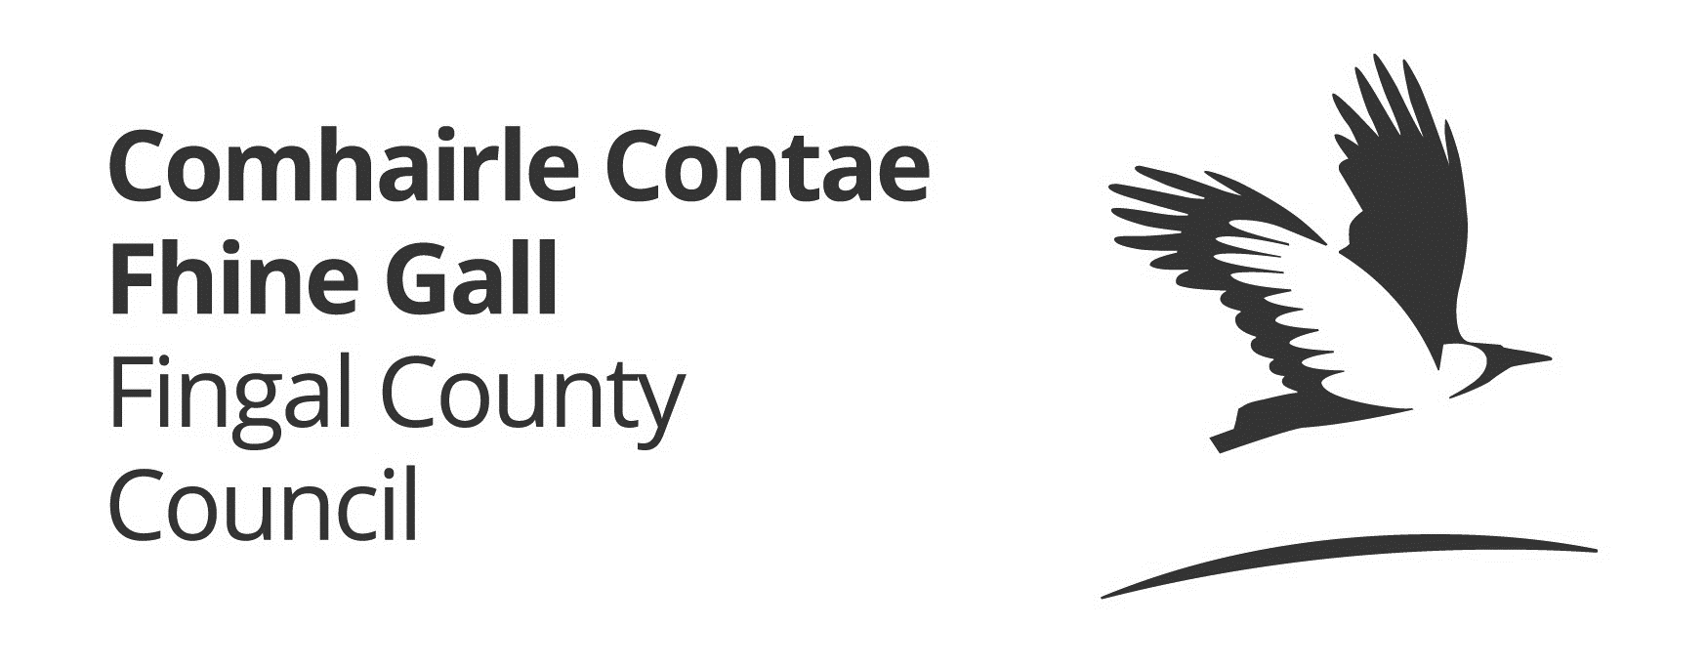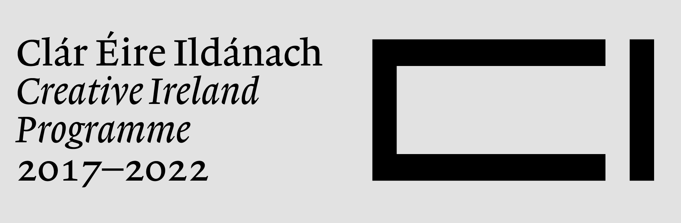

APPLICATION FORM

Name of Applicant ___________________________________

Project Details : ___________________________________

___________________________________

Amount Requested: ___________________________________

For office use only
Amount awarded: ___________________
Signed: ___________________________
Date: _____________________________

Section 1: Applicant

Lead contact details
Name of Applicant :

Address of Applicant :

Contact Person:

Role with group:

Email:

Telephone:

GROUP / ORGANISATION DETAILS
(Where applicable)
Name of Group/Organisation:
State nature/primary activity of organisation:

Is your group/organisation affiliated to any relevant local, regional or national body?

Company Registration No.

Does your company have Charitable Status? If so please state Charity No.

Section 2: Project/Event

Details of Proposed Project/Event:
Name of Project/event:
Commencement Date of project/event:

Target Audience/Participants:

Audience profile:

Evidence of Covid compliance in adherence with current government guidelines ( if applicable)

Provide details of proposed project/event, ensuring to outline what themes your project will cover under the Fingal Creative Programme including:

Community Wellbeing and Culture
Heritage
Music
STEAM (Science, Technology, Engineering, Arts and Mathematics)
Irish Language

Attach extra sheets if required.

Section 3: Management and Staffing

Project/Event Staffing

Number of Board Members:

Number of Voluntary Committee Members:
Number of Full time paid staff:

Number of Part time paid staff:

Number of Volunteers/interns:

Key Staff: Please provide details of the background and experience of key staff/personnel:

Committee/Board Members: Please provide details of the background and experience of the principal members of the organising committee/board

Other Staff/Contractors: Please list companies hired to supply/provide goods and/or services to the Project/event:

Section 4: Sales & Marketing Strategy
How do you intend to promote the Project/ event in line with the Creative Ireland Initiative?

Section 5: Projected Income and Expenditure

INCOME | €
Ticket Sales

Project/Event Merchandise

Sponsorship

FLAG Funding

LEADER Funding

Arts Council

Local Authority Grant Funding (including Fingal County Council and other Local Authorities)

Fáilte Ireland

Grants (Other, please specify)

Borrowing

Fundraising

Other (please specify)

TOTAL INCOME

EXPENDITURE | €
Artist/Performers fees

PA/AV Equipment Costs

Infrastructure Costs

Technical costs and fees

Security Costs

Garda Costs

Marketing Costs (including PR, social media, leafleting etc.)

Site branding and signage

Operational Costs (including staff salaries & costs, office rental & rates, heat & light, phone & internet, postage, office supplies & stationary, IT Support, accountancy & legal fees, insurance, IT costs including hosting & maintenance)

Printing

Covid Compliance Plan

TOTAL EXPENDITURE

TOTAL INCOME LESS EXPENDITURE

Disclaimer – please read carefully
It will be a condition of any application for funding that the applicant has read, understood and accepted the following:

- Fingal County Council shall not be liable to the applicant, or any other party, in respect of any loss, damage or costs of any nature arising directly or indirectly from:

- The application or the subject matter of the application
- The rejection for any reason of any application

- Fingal County Council shall not be held responsible or liable, at any time in any circumstances, in relation to any matter whatsoever arising in connection with the administration of activities.

Section 6: Declaration
Declaration by Applicant(s)

I/We apply for funding of €_________ towards the total cost of the project/event.

I/we have read and understood the information and criteria as set out by Fingal County Council.

I/we certify that all information provided in this application, and all information given in any documentation submitted in support of the application is truthful and accurate.

I/we acknowledge that any personal information submitted to Fingal County Council will be obtained and processed in line with the Data Protection Acts 1998, 2003 and GDPR.

By submitting an application, applicants agree to the processing and disclosure of the applicant’s information by the Council, if required, for fund administration, reporting, evaluation and audit purposes; and successful applicants further consent to the disclosure of this information (e.g. name of successful applicant, amount of award, event details etc.) by Fingal County Council in connection with the marketing or promotion of the scheme and event.

Signed: _____________________________ Date: _________________

Name (in block capitals):______________________________________

On behalf of (organisation's name): _____________________________

FINGAL COUNTY COUNCIL DATA PROTECTION NOTICE

Fingal County Council is committed to protecting and respecting your privacy. This Data Protection Notice tells you about your privacy rights and sets out how we, as a Controller, collect, use, process and disclose your personal data relating to your interactions with us.

Information we may collect from you
Personal data means any information about an individual from which that person can be identified. It does not include data where the identity has been removed (anonymous data). We may collect and process any type of personal data you provide to us in the course of your interactions with us.

How we use personal data we collect
We will only use your personal data for the purposes and legal bases set out in the table below.

Purpose(s) for Processing | Legal Basis for Processing
- To process application in respect of fund administration  - Request insurance documentation and other such documents  - Evaluation of application  - Audit purposes | - Eligibility Criteria under the Scheme

Records Retention Policy
Fingal County Council has a Record Retention Policy which sets out the time period for which your personal data will be retained by Fingal County Council and what will happen to it after the required retention period has expired.

Your personal data will only be held for as long as necessary for the purpose(s) for which it was obtained. The criteria used to determine our retention periods include (i) the length of time we have an ongoing relationship and/or provide our services; (ii) whether there is a legal requirement to which we are subject; and (iii) whether the retention is advisable in light of our legal position (such as in regard to applicable statutes of limitations, litigation or regulatory investigations).

Please contact us if you wish to obtain further information concerning our retention periods or visit our website at www.fingal.ie

Security and where we store your personal data
We are committed to protecting the security of your personal data. We use a variety of security technologies and procedures to help protect your personal data from unauthorised access and use. As effective as modern security practices are, no physical or electronic security system is entirely secure. We cannot guarantee the complete security of our database, nor can we guarantee that information you supply will not be intercepted while being transmitted to us over the Internet. We have implemented strict internal guidelines to ensure that your privacy is safeguarded at every level of our organisation. We will continue to revise policies and implement additional security features as new technologies become available.

Your Rights
You have the right to request access to personal data held about you, obtain confirmation as to whether data concerning you exists, be informed of the content and source of the data and check its accuracy. In addition, if the data held by us is found to be inaccurate you have the right to change, remove, block, or object to the use of personal data held by Fingal County Council. In certain circumstances blocking access to data may delay or remove access to a service where the data is required by law or for essential purposes related to delivery of a service to you. Please note that to help protect your privacy, we take steps to verify your identity before granting access to personal data. To exercise these rights you should take the following steps,

All requests for personal data held by Fingal County Council must be made in writing by post or email to:

Information & Data Management Officer
Corporate Affairs & Governance Department,
Fingal County Council, Civic Offices, Blanchardstown
Email: data.officer@fingal.ie

Right of Complaint to the Office of the Data Protection Commissioner

If you feel the Council is not respecting your data protection rights, please contact us. If you are not satisfied with our response, you may contact the Office of the Data Protection Commissioner as follows:

The Office of the Data Protection Commissioner
Canal House, Station Road, Portarlington, Co. Laois
LoCall: 1890 252 231, Telephone: 057 8684800, Fax: 057 8384757
Email: info@dataprotection.ie
Website: http://www.dataprotection.ie

